**Usability Test - ToDoist**

**Plan:**

* Problem Statement: In this test, we are focusing on how a student user would set and edit tasks in ToDoist. Additionally, we are testing the same user’s ability to customize their profile and planner experience.
* Environment: In class
* User: Busy college student
* Roles: Moderator (Kennedy Kaufman), Data Logger (Jack Billings), Observer (both).
* Pre-Questionnaire
  + “What is your age?”
  + “How comfortable are you using technology/mobile devices?”
  + “Do you use a planner? If so, what?”
  + “What else helps you with time management and organizing tasks?”
* Introduction
  + Scenario: “For this test, you will imagine you are a college student who struggles with scheduling. You downloaded the app, ToDoist, to help you with your time management and remembering tasks.”
  + Goal: “Observe how users interact with ToDoist for time management, focusing on setting and editing tasks and customization of a personal profile.”
* Scripts
  + Plan: Thank user for participating. Describe scenario and goal of the test. Define relationships with the system. Explain tasks and roles, “I will not provide hints or help unless you ask, I will observe you silently until you signal you are finished with a task. I may ask clarification during the test. Please remember to think aloud and explain your thought process.”
  + Measures of Success: Speed/efficiency (with a stopwatch), Satisfaction (verbal), Confidence (verbal), Success (tally), Error (tally). (See Table below)
* Tasks
  + Add a task to do your homework.
    - * Add Assignment due date
      * Add a Digital Reminder  (explain if they don't know what it is)
      * Add a task to project labeled “Work.”
      * Set priority
    - Questions to ask:
      * Difficulty of tasks? What was easy? Satisfied? Would you change and how? Are you confident?
  + Find help for using the app/where would you go to find help if you ran into a problem?
    - Questions
      * Where did you go? Did you find help? Difficulty of tasks? What was easy? Satisfied? Would you change and how? Are you confident?
  + How would you ‘complete’ a task and mark it as finished?
  + Search for an old task
  + Change your time zone to Central Time
  + Where would you go to purchase the full version? (Not through reminders)
  + Change your email address without logging out.
* Post-Questionnaire
* Overarching questions, determine what user is thinking at end

1. Overall, how did you feel? What was most difficult? Why? Have you run into similar problems before?
2. What would you change right now if you could? How?
3. Would you recommend this app to a friend? Why or why not?

Logging Forms

|  |  |  |
| --- | --- | --- |
|  | User 1 | User 2 |
| Task 1: Add a task to do your homework |  |  |
| Task 2: Add a due date to that task | ! | ! |
| Task 3: Add a reminder to that task | ! | ! |
| Task 4: Label that task as work |  |  |
| Task 5: Change the priority of that task |  |  |
| Task 6: Mark a task as ‘completed.' |  | ! |
| Task 7: Find help for using the app if you ran into a problem |  | ! |
| Task 8: Search for a task |  |  |
| Task 9: Change the time zone to Central Time |  |  |
| Task 10: Change your email address |  |  |
| Task 11: Go to where you would purchase the full version of ToDoist |  |  |

|  |  |
| --- | --- |
| Success | Had difficulty but finished the task without help |

**User 1**

**Task 1: Add a task.**

Success? [x]

|  |  |  |  |
| --- | --- | --- | --- |
| **Time** | **Screen** | **Type** | **Notes** |
| 1:10 | Home screen |  | Task start |
| :07 |  |  | Task complete |
|  |  |  |  |
|  |  |  |  |
|  |  |  |  |
|  |  |  |  |
|  |  |  |  |

CU: comment by user E: error !: critical incident

**Task 2: Add a task to do your homework and assign a due date to it.**

Success? [x]

|  |  |  |  |
| --- | --- | --- | --- |
| **Time** | **Screen** | **Type** | **Notes** |
| 1:23 |  |  | Task start |
| :10 |  |  |  |
|  |  |  |  |
|  |  |  |  |
|  |  |  |  |
|  |  |  |  |
|  |  |  |  |

CU: comment by user E: error !: critical incident

Due date: click on homework, changed due date, clicked send

**Task 3: Add a reminder to do your homework.**

Success? [x]

|  |  |  |  |
| --- | --- | --- | --- |
| **Time** | **Screen** | **Type** | **Notes** |
| 1:40 |  |  | Task start |
| :03 | Home |  | Wrong button clicked |
| :10 |  |  | Wrong button |
| :25 |  |  | Found task |
| :30 |  |  | Task complete |
|  |  |  |  |
|  |  |  |  |

CU: comment by user E: error !: critical incident

Add reminder: can't swipe right, can't click on day, found homework, press alarm clock

**Task 4: Label task as work.**

Success? [x]

|  |  |  |  |
| --- | --- | --- | --- |
| **Time** | **Screen** | **Type** | **Notes** |
| 2:17 | Home screen |  | Task start |
| :10 | Edit screen |  | Task complete |
|  |  |  | Using big yellow + button |
|  |  |  |  |
|  |  |  |  |
|  |  |  |  |
|  |  |  |  |

CU: comment by user E: error !: critical incident

**Task 5: Set the priority of the homework task.**

Success? [x]

|  |  |  |  |
| --- | --- | --- | --- |
| **Time** | **Screen** | **Type** | **Notes** |
| 2:38 | Home screen |  | Task start |
| :12 | Edit screen |  | task complete |
|  |  |  |  |
|  |  |  |  |
|  |  |  |  |
|  |  |  |  |
|  |  |  |  |

CU: comment by user E: error !: critical incident

Hardest: change day couldn’t find next day

If could change: if swipe day. Cant do next day

**Task 6: How would you ‘complete’ a task and mark it as finished?**

Success? [x]

|  |  |  |  |
| --- | --- | --- | --- |
| **Time** | **Screen** | **Type** | **Notes** |
| 4:50 | Main |  | Task start |
| :10 | Next 7 days |  |  |
| :13 | Click on tasks |  |  |
| :15 | Click green button |  | Task complete |
|  |  |  |  |
|  |  |  |  |
|  |  |  |  |

CU: comment by user E: error !: critical incident

**Task 7: Find help for using the app/where would you go to find help if you ran into a problem?**

Success? [x]

|  |  |  |  |
| --- | --- | --- | --- |
| **Time** | **Screen** | **Type** | **Notes** |
| 3:50 | Main |  | Task start |
| :02 | Three dots |  |  |
| :10 | Another menu on left |  |  |
| :12 | settings |  |  |
| :18 | support |  |  |
|  |  |  |  |
|  |  |  |  |

CU: comment by user E: error !: critical incident

Satisfied with experience? Not that difficult-delay because thought top right would support button. Change to help me button to be in top 3 dots

**Task 8: Search for an old task**

Success? [x]

|  |  |  |  |
| --- | --- | --- | --- |
| **Time** | **Screen** | **Type** | **Notes** |
| 5:10 |  |  | Task start |
| :01 | Search button |  |  |
| :02 | Meeting shows up clicked it |  |  |
|  |  |  |  |
|  |  |  |  |
|  |  |  |  |
|  |  |  |  |

CU: comment by user E: error !: critical incident

**Task 9: Change your time zone to Central Time**

Success? [x]

|  |  |  |  |
| --- | --- | --- | --- |
| **Time** | **Screen** | **Type** | **Notes** |
| 5:23 |  |  | Task start |
| :04 | Top left button |  |  |
| :08 | settings |  |  |
| :10 | Day and time |  |  |
| :27 | Trouble finding central |  |  |
|  |  |  |  |
|  |  |  |  |

CU: comment by user E: error !: critical incident

**Task 10: Change your email address**

Success? [x]

|  |  |  |  |
| --- | --- | --- | --- |
| **Time** | **Screen** | **Type** | **Notes** |
|  |  |  | Task start |
| 6:00 | settings |  |  |
| :02 | account |  |  |
| :05 |  |  |  |
|  |  |  |  |
|  |  |  |  |
|  |  |  |  |

CU: comment by user E: error !: critical incident

**Task 11: Where would you go to purchase the full version of ToDoist? How much is it?**

Success? [x]

|  |  |  |  |
| --- | --- | --- | --- |
| **Time** | **Screen** | **Type** | **Notes** |
|  |  |  | Task start |
| 6:12 | Settings |  |  |
| :06 | Pop-up |  |  |
| :11 | Upgrade to premium |  |  |
|  |  |  |  |
|  |  |  |  |
|  |  |  |  |

CU: comment by user E: error !: critical incident

**Pre-test**

Age: 22

Technology level: Very comfortable with technology

Uses planner: Uses Google calendar-uses notifications and alarm clocks

**Post-test**

Most trouble: settings was weird. Not as responsive. Notifications-confirmation after you leave. Wouldn’t change to this

Found similar problems before: No

Recommend: yeah if they don’t have google calendar

**User 2**

Task 1: Add a task.

Success? [X]

|  |  |  |  |
| --- | --- | --- | --- |
| Time | Screen | Type | Notes |
| 1:46 |  |  | Task start |
| :02 | Main |  |  |
| :10 | Input task |  | Completed task |

CU: comment by user E: error !: critical incident

Task 2: Add a task to do your homework and assign a due date to it.

Success? [X]

|  |  |  |  |
| --- | --- | --- | --- |
| Time | Screen | Type | Notes |
| 2:11 |  |  | Task start |
| :02 | Main |  |  |
| :05 | Input task | E | Clicked the date at the top of screen |
| :05 | Input task | E | Clicked on the tags button |
| :10 | Input task |  | Completed task |

CU: comment by user E: error !: critical incident

Task 3: Add a reminder to do your homework.

Success? [X]

|  |  |  |  |
| --- | --- | --- | --- |
| Time | Screen | Type | Notes |
| 2:50 |  |  | Task start |
| :15 | Main | E | Had trouble finding Homework task |
| :02 | Input task | E | Clicked on labels |
| :02 | Input task | E | Clicked on priority button |
| :02 | Input task |  | Completed task |

CU: comment by user E: error !: critical incident

Task 4: Label task as work.

Success? [X]

|  |  |  |  |
| --- | --- | --- | --- |
| Time | Screen | Type | Notes |
| 4:15 |  |  | Task start |
| :05 | Input task | E | Clicked the wrong button |
| :03 | Input task | E | Clicked completed task button |
| :03 | Input task | E | Clicked on the calendar button |
| :02 | Input task |  | Completed task |

CU: comment by user E: error !: critical incident

Task 5: Set the priority of the homework task.

Success? [X]

|  |  |  |  |
| --- | --- | --- | --- |
| Time | Screen | Type | Notes |
| 4:38 |  |  | Task start |
| :03 | Input task |  | Completed task |

CU: comment by user E: error !: critical incident

Task 6: How would you ‘complete’ a task and mark it as finished?

Success:

Success? [X]

|  |  |  |  |
| --- | --- | --- | --- |
| Time | Screen | Type | Notes |
| 4:48 |  |  | Task start |
|  | Main |  | Completed task |

CU: comment by user E: error !: critical incident

Task 7: Find help for using the app/where would you go to find help if you ran into a problem?

Success:

Success? [X]

|  |  |  |  |
| --- | --- | --- | --- |
| Time | Screen | Type | Notes |
| 6:34 |  |  | Task start |
| :02 | Main |  |  |
| :02 | Left menu |  |  |
| :04 | Setting |  |  |
| :02 | Support |  |  |
|  | Knowledge base |  | Task completed |

CU: comment by user E: error !: critical incident

Task 8: Search for an old task.

Success:

Success? [X]

|  |  |  |  |
| --- | --- | --- | --- |
| Time | Screen | Type | Notes |
| 7:39 |  |  | Task start |
| :02 | Main |  |  |
| :01 | Top right button |  |  |
|  | Search |  | Task completed |

CU: comment by user E: error !: critical incident

Task 9: Change your time zone to Central Time

Success:

Success? [X]

|  |  |  |  |
| --- | --- | --- | --- |
| Time | Screen | Type | Notes |
| 7:47 |  |  | Task start |
| :06 | Main |  |  |
|  | Top right button | E | Clicked on the wrong button |
| :02 | Top left button |  |  |
| :01 | Settings |  |  |
| :01 | General |  |  |
| :01 | Date and time |  |  |
|  | Time zone |  | Task completed |
|  |  |  |  |
|  |  |  |  |

CU: comment by user E: error !: critical incident

Task 10: Change your email address

Success:

Success? [X]

|  |  |  |  |
| --- | --- | --- | --- |
| Time | Screen | Type | Notes |
| 8:05 |  |  | Task start |
| :01 | Date and time |  |  |
| :01 | General |  |  |
|  | Logout |  | Task completed |

CU: comment by user E: error !: critical incident

Task 11: Where would you go to purchase full version of ToDoist? How much is it?

Success:

Success? [X]

|  |  |  |  |
| --- | --- | --- | --- |
| Time | Screen | Type | Notes |
| 8:25 |  |  | Task start |
| :01 | General |  |  |
|  | Purchase full version |  | Task completed |

CU: comment by user E: error !: critical incident

**Pre-test**

Age: 21

Technology level: Very comfortable with technology

Uses planner: No

**Post-test**

Most trouble: Finding where tasks were saved

Found similar problems before: Misleading features like where the tasks are being saved and which buttons do what

Recommend: Would get the job done but only need tasks, event, and alarm and there's too much going on. Labels and priority aren’t necessary, and if you do, you should have more. Too complicated-superfluous

**Report**

**Purpose/Goals: What is the project? Why are you doing it? Why are you designing it the way you are? Why is usability testing needed? What are your specific research questions?**

Our project is a usability test about an app called ToDoist. ToDoist is a planner app used to help people with time management and remind them of tasks. We are conducting the usability test on ToDoist because it is an app that we feel could be improved. We designed our usability test in a way to test how well users can add, update, and complete tasks in the app. We also designed the test to see how well users can set reminders for tasks and navigate to useful parts of ToDoist. The usability testing is needed because we want to learn more about how well users can navigate through the app, focusing mostly on the tasks section of ToDoist. The usability test will give us more insight into what needs to be improved in ToDoist. Our specific research questions are how does a student user set and edit tasks in ToDoist and how well can that same user customize their profile and planner experience.

**Problem statement: What is the particular issue/problem your product is designed to address? What are the particular questions you hope to answer?**

ToDoist is designed to help users with time management, which includes setting due dates, reminders, and completions for tasks. It also has customizable features to help the user's planner experience. The usability test addresses how well ToDoist completes these objectives. The questions we hope to answer are how easy is it for users to set and edit tasks, as well as, customize their profile and planner experience? We answered these questions using a logging form to show how well users were able to complete each task.

**User: Detailed description of your “user” or users. Who are they? What they know and do, related to the activity you are designing your guide for? What is their “situation of use?” What are their needs? Motives?**

Our first user was 21 years old and our second user was 22 years old. They are both students in the School of Information at the University of Michigan. They are both experienced with technology. The first user does not regularly use a planner, while the second user uses Google calendars as a planner. They both use digital reminders to remind them of their tasks. Their “situation of use” is that they are students who struggle with scheduling. Therefore, they downloaded the app, ToDoist, to help with their time management and remembering tasks. So, their need is a system, or planner, to help them with their time management specifically by setting due dates for tasks and reminders for those tasks. Their motivation is to complete their tasks promptly and not forgot about tasks.

**Analysis**

We began developing our usability test by crafting an introductory script.  We pulled introduction questions from our previous personas survey: age, familiarity with technology, planner use, and time management methodology. This helped us understand our user on a deeper level.

Next, we reviewed the slides to create other necessary introductions. This included an opening statement that thanked the user for participating and explained important steps to the test (*we are testing the system, not the user*). This included reminding them to think aloud, declare when they are finished, and doing their best not to ask for help (but always, if frustrated, they can skip a task). We told the users to play the role of a busy student, which matched their true identities. Our post-questionnaire captured reactions from the users by recapping key moments and observations. For example, if we observed a difficult task, we would revisit it, later on, to see how a user processed the challenge. Other example questions included the most difficult tasks, how they would change a feature and if they would personally recommend ToDoist to a friend.

The logging forms were designed from the example in the slides. We measured success Speed/efficiency (with a stopwatch), Satisfaction (verbal), Confidence (verbal), Success (tally), Error (tally). Speed was important because we hoped a user could finish a task quickly. The stopwatch was also helpful as it time stamped when a user experienced a problem, so when going back through audio files, we could reference the time of the error. Satisfaction and confidence were measured with verbal questions to capture a user’s feelings.

To recap, our main goal of this test was to capture how a user’s interaction with task setting and personalization in ToDoist. To better understand these questions, we created 7 tasks varying in difficulty. First, we started with the most important part of our app, setting a task. To no surprise, both users found this very easy, being drawn to the app’s large, yellow ‘+’ symbol. The color and location of the button promoted a satisfying experience.

We then added supplementary activities to task setting. First, we asked users to assign a due date. Both users searched for about 30 seconds trying to find a button. Both users verbalized they liked the design of the due date page but had trouble finding the button. We recommend making it easier to locate but keep the overall design. Next, we asked users to assign a digital reminder. Here, we encountered major issues. Our first user lost his task after setting its due date. The issue we discovered was that ToDoist separates tasks by due date. Once the task was dated as due tomorrow, it was moved away from the home screen. User One had trouble finding it and voiced this in the post-questionnaire as the most frustrating aspect. User Two had to press three different buttons before finding the edit page and successfully setting a reminder. User two voiced she had experience setting digital reminders, which user one did not, so this may have played a factor in usability. Lastly, we asked users to label and set a priority for the task. Since these two features are located on the same page as reminders, they both found it easily. Both users began showing signs of getting familiarity with the app. It was good that they intuitively knew the task edit page would allow priority setting and labeling.

Next, we asked the user to navigate where they believed they could find help using the app (a support page). User Two clicked a three dot symbol which she thought was the menu. She was wrong and voiced her concern. She stated in the post-questionnaire that it was much more intuitive for the menu and help button to be symbolized by the three dots. Otherwise, after about 25 seconds of scanning, she found it. User One took around 20 seconds to find it, which is still a bit long. However, they were both new users to the app, so there is a learning curve.

The rest of the tasks were marking a task complete, searching for a task, changing time zone, change email, and purchase the full version. User One finished all these tasks without issues. User Two ran into the same issue as User One when trying to complete a task. Since ToDoist sorts tasks on the due date, user two couldn’t find the task to complete it as it got moved to a different screen (not on the homepage). She voiced her dissatisfaction with this in the post-questionnaire.

It is interesting, even as both users claimed to be ‘tech savvy,' they both ran into a major issue with ToDoist in locating tasks and setting digital reminders. Thus, for users with poor tech familiarity, the app could have severe problems. For our A/B test, we studied the symbol and placement of the digital reminder button. The usability test confirmed our hypothesis as users have trouble setting reminders.

If we could go back, we would add another person to our group. It was difficult with only two people because one was focused on vigorously taking notes, while the other focused on facilitating a conversation. Adding another person, the silently observe could help see quick or minor observations. Also, a third person could record the event. Also, our app updated after we designed our test. It changed features like setting a reminder and label as “Premium” features, which only affected the test in minor ways. We would also conduct our interview in a private area, away from distractions and background noise. This helps when reviewing notes and keeping a user focused. Lastly, we would go back and rehearse the actual test and practice asking questions. This helps iron out kinks and better frame questions.

**Consent Forms**

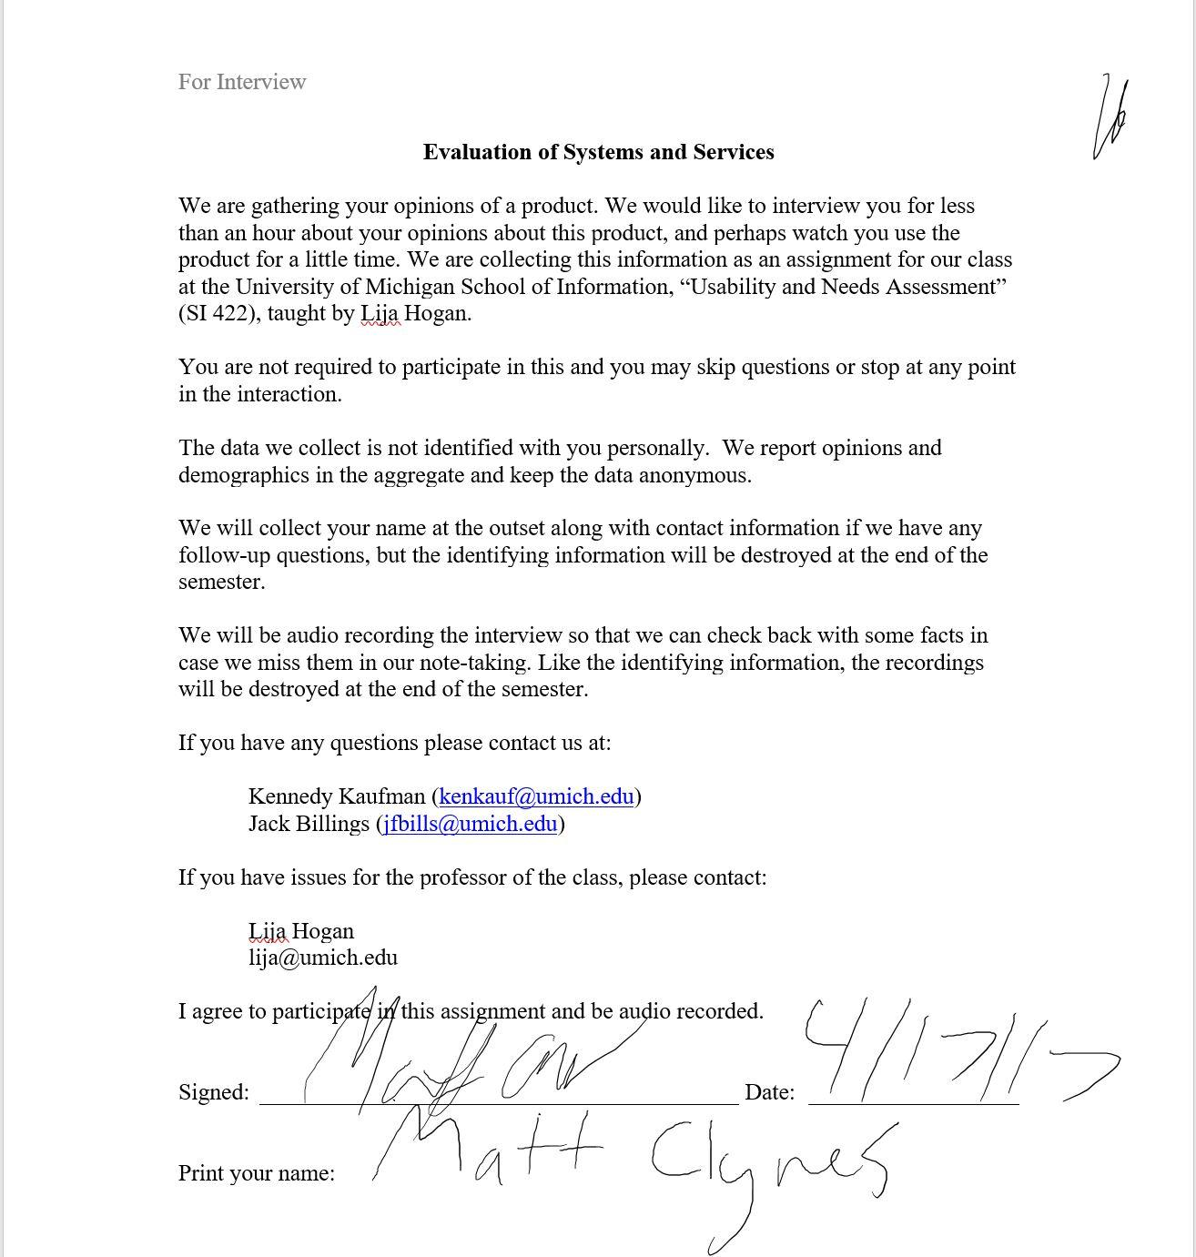

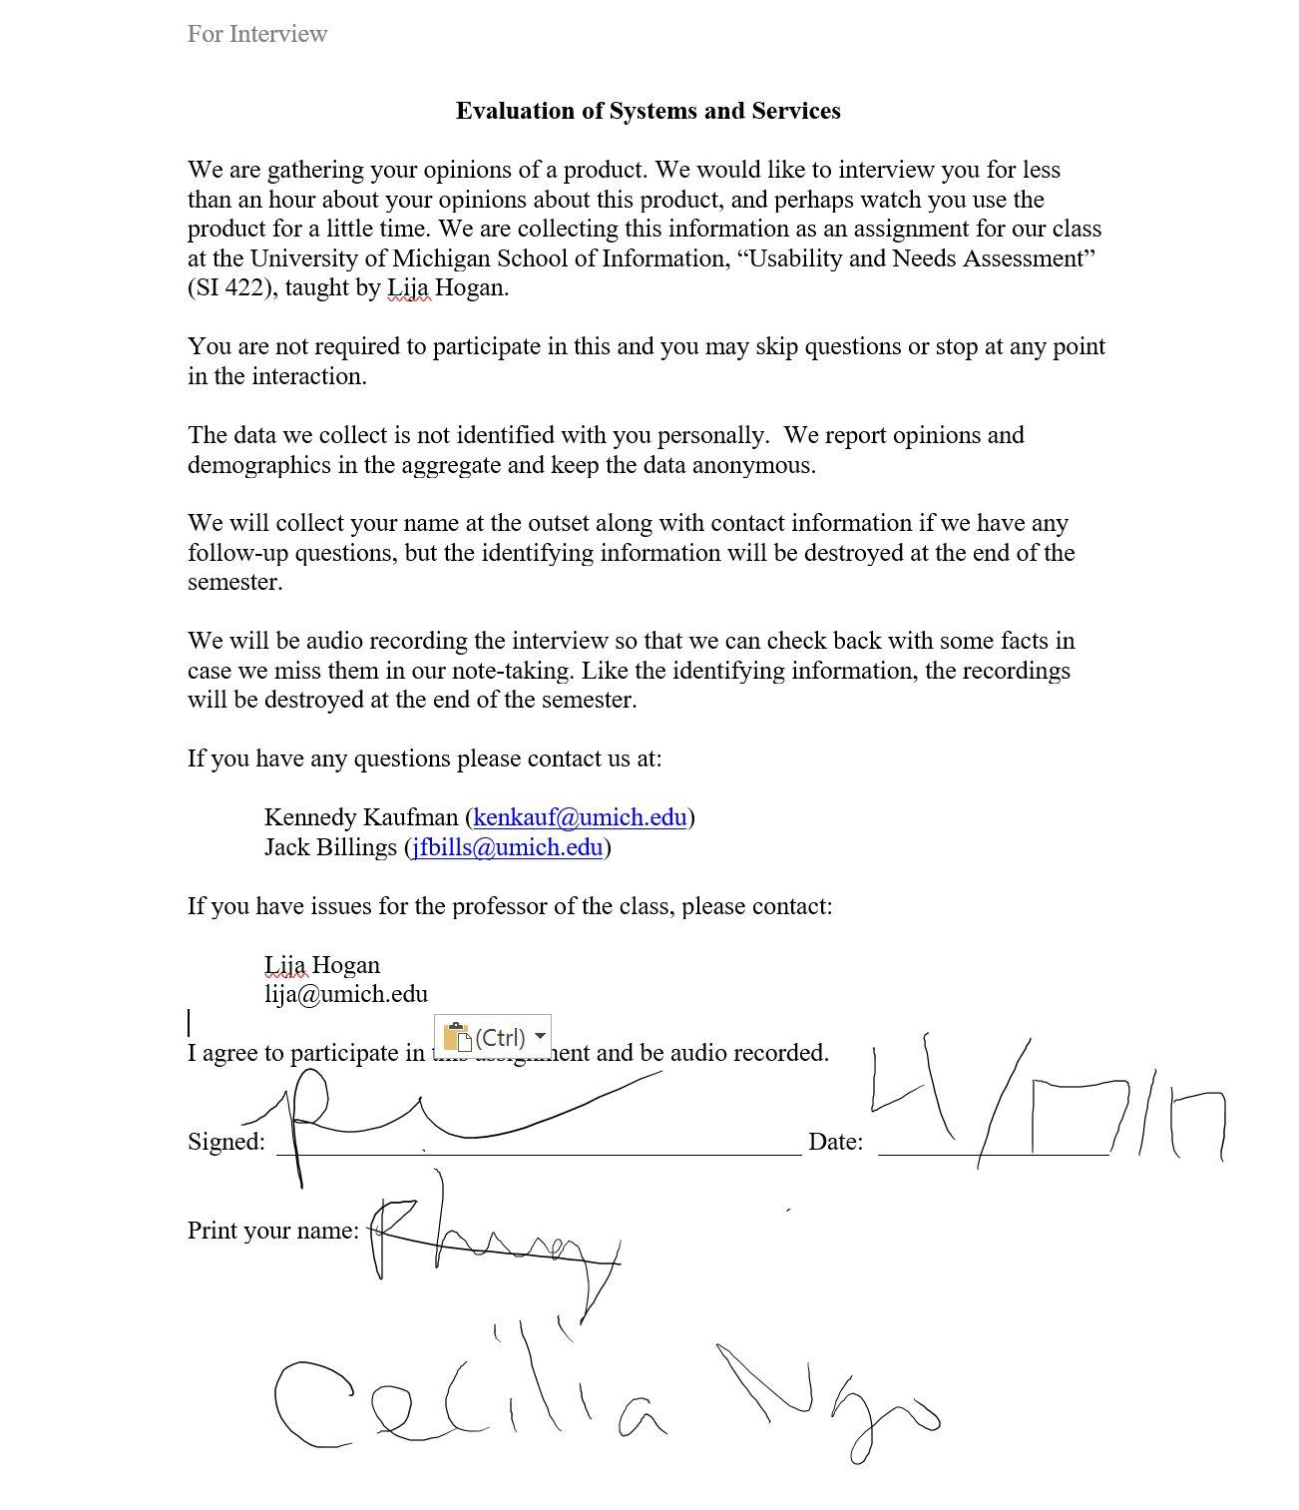

**Audio Files**

Audio 1: <https://drive.google.com/open?id=0BykJsF3b5A2xMFRqaTBfa21YM2FSM1d4TnlFTVl0eUZqMVBR>

Audio 2: <https://drive.google.com/open?id=0BykJsF3b5A2xcGJtcXduNUxsb2FScTBqTGNyd0ZTOFhqVWhR>

**Appendix**

*Pre-questionnaire responses & Post-questionnaire response*

* User 1
  + **Pre-test**
    - Age: 22
    - Technology level: Very comfortable with technology
    - Uses planner: Uses Google calendar-uses notifications and alarm clocks
  + **Post-test**
    - Most trouble: settings was weird. Not as responsive. Notifications-confirmation after you leave. Wouldn’t change to this
    - Found similar problems before: No
    - Recommend: yeah if they don’t have google calendar
* User 2
  + **Pre-test**
    - Age: 21
    - Technology level: Very comfortable with technology
    - Uses planner: No
  + **Post-test**
    - Most trouble: Finding where tasks were saved
    - Found similar problems before: Misleading features like where the tasks are being saved and which buttons do what
    - Recommend: Would get the job done but only need tasks, event, and alarm and there's too much going on. Labels and priority aren’t necessary, and if you do, you should have more. Too complicated-superfluous

*Task performance*

* See ‘Log Forms’ on Page 2

*Logging notes*

* See ‘Log Forms’ on Page 2

*Audio files*

* See ‘Audio Files’ on Page 12